Frosty the snowman is made from two uniform spherical snowballs, of initial radii 2R and 3R. The smaller (which is his head) stands on top of the larger.
As each snowball melts, its volume decreases at a rate which is directly proportional to its surface area, the constant of proportionality being the same for both snowballs. During melting each snowball remains spherical and uniform.
Let V and h denote Frosty's total volume and height at time t.
- Show that, for $2R<h≤10R$, $\frac{dV}{dh}=\frac{π}{8}\left(h^{2}+4R^{2}\right)$
- Derive the corresponding expression for $0≤h<2R$
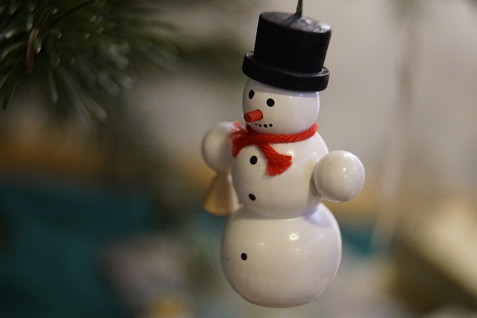
- Sketch $\frac{dV}{dh}$ as a function of h for $4R≥h≥0$.
Hence give a rough sketch of V as a function of h.

Frosty the snowman is made from two uniform spherical snowballs, of initial radii 2R and 3R. The smaller (which is his head) stands on top of the larger.
As each snowball melts, its volume decreases at a rate which is directly proportional to its surface area, the constant of proportionality being the same for both snowballs. During melting each snowball remains spherical and uniform.
Let V and h denote Frosty's total volume and height at time t.
- Show that, for $2R<h≤10R$, $\frac{dV}{dh}=\frac{π}{8}\left(h^{2}+4R^{2}\right)$
- Derive the corresponding expression for $0≤h<2R$
- Sketch $\frac{dV}{dh}$ as a function of h for $4R≥h≥0$.
Hence give a rough sketch of V as a function of h.

