Frosty the snowman is made from two uniform spherical snowballs, of initial radii 2R and 3R. The smaller (which is his head) stands on top of the larger.
As each snowball melts, its volume decreases at a rate which is directly proportional to its surface area, the constant of proportionality being the same for both snowballs. During melting each snowball remains spherical and uniform.
- When Frosty is half his initial height, show that the ratio of his volume to his initial volume is
37 : 224 .
- What is this ratio when Frosty is one-tenth of his initial height?
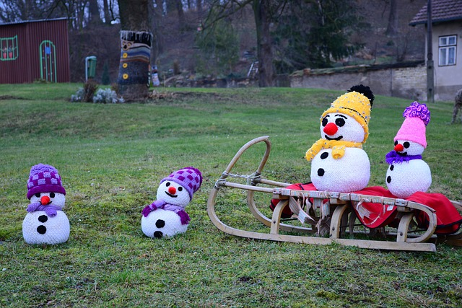
Frosty the snowman returns in the problem
“A Frosty Puddle”

nrich.maths.org/14932

Frosty the snowman is made from two uniform spherical snowballs, of initial radii 2R and 3R. The smaller (which is his head) stands on top of the larger.
As each snowball melts, its volume decreases at a rate which is directly proportional to its surface area, the constant of proportionality being the same for both snowballs. During melting each snowball remains spherical and uniform.
- When Frosty is half his initial height, show that the ratio of his volume to his initial volume is
37 : 224 .
- What is this ratio when Frosty is one-tenth of his initial height?
Frosty the snowman returns in the problem
“A Frosty Puddle”

nrich.maths.org/14932
Frosty the snowman returns in the problem
“A Frosty Puddle”

nrich.maths.org/14932

