First I doubled 18 to  get 36.  Then I doubled that to  get 72.  Then I added 18 again. | I took 18 and I halved that, which is 9.  9x5 is 45, 9x5 is 45.  Then I added 45 and 45 together.
I separated 18 into 8 and 10.  8x5 is 40. 10x5 is 50.  I then added 40 and 50 together. | I did 9x10 instead of 18x5 because that’s the same thing.
I did 20x5, which is 100.  Then I took away 2x5, which is 10. | A  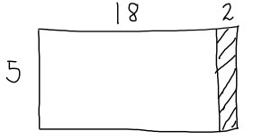
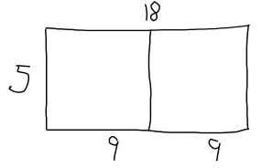  B | 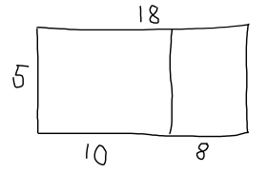  C
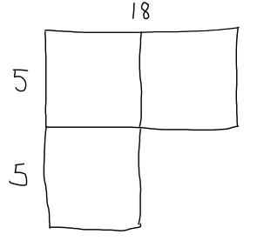  D | 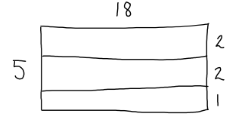  E

