For the first part of this task, you're going to try to answer a calculation in your head, without using pencil or paper. When you're ready, have a go at the calculation below.
What is 18 x 5?
Jot down your answer.

The answer is definitely not the most interesting part of this problem! Much more interesting is thinking about the way you arrived at your answer.
Below you can read what five learners said when they were asked how they worked out their answer:
Bryan:
First I doubled 18 to get 36.
Then I doubled that to get 72.
Then I added 18 again.
Neil:
I took 18 and I halved that, which is 9.
9x5 is 45, 9x5 is 45.
Then I added 45 and 45 together.
Sammi:
I separated 18 into 8 and 10.
8x5 is 40. 10x5 is 50.
I then added 40 and 50 together.
Ricardo:
I did 9x10 instead of 18x5 because that's the same thing.
Jaime:
I did 20x5, which is 100.
Then I took away 2x5, which is 10.
Was your method the same as any of these? If not, describe what you did.
We can also draw each of these ways of working out 18x5. (We might say we can represent each one visually.)
Can you match each drawing below to one of the methods described above? (We've labelled each of the drawings with a letter to make it easier to refer to a particular one.)

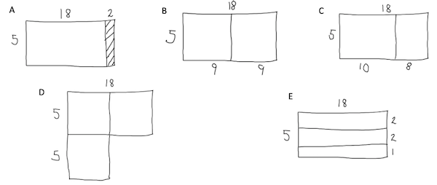

How did you decide on the pairings?
If you used a different method, create a drawing of your method too.

