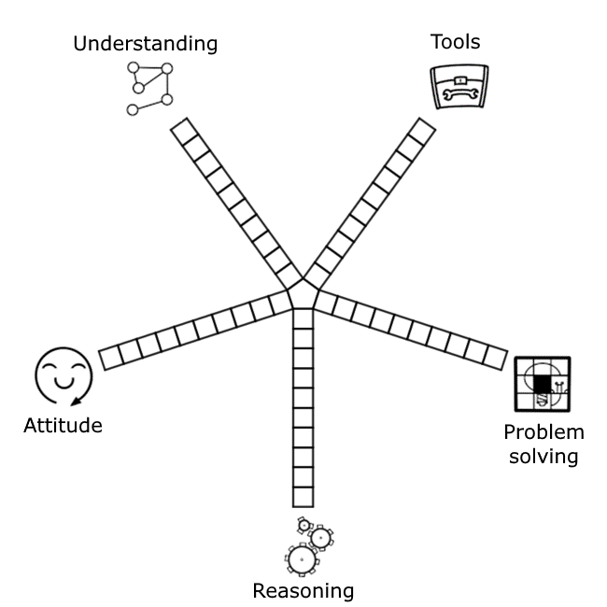

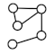 | Understanding | Maths is a network of linked ideas. I can connect new mathematical thinking to what I already know and understand.
 | Tools | I have a toolkit that I can choose tools from to help me solve problems. Practising using these tools helps me become a better mathematician.
 | Problem solving | Problem solving is an important part of Maths. I can use my understanding, skills and reasoning to help me work towards solutions.
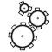 | Reasoning | Maths is logical. I can convince myself that my thinking is correct and I can explain my reasoning to others.
 | Attitude | Maths makes sense and is worth spending time on. I can enjoy Maths and become better at it by persevering.

