 | Understanding
 | Tools
 | Problem solving
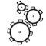 | Reasoning
 | Attitude

