In this activity, you are going to arrange rods to make different lengths.

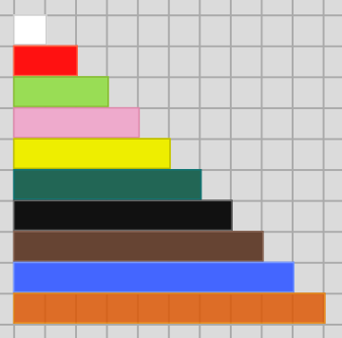
Start by choosing three different colours of rod.
For example, you might choose:
- light green (which covers three squares)
- pink (which covers four squares)
- dark green (which covers six squares)

The challenge is to try to make as many different lengths between 1 and 10 as you can without using rods more than once.

You can make 3 by just using the light green rod.


You can make 7 by using a light green
and a pink rod.

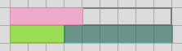
You can make 5 by using all three rods (there is an empty space that is five squares long).

It’s not possible to make 8 with these three rods.
If you were allowed to use a rod twice, you could use two pinks together to make 8, but you are only allowed to use each rod once.

Now that you have seen an example, choose three colours of your own, and see how many different lengths from 1 to 10 you can make.

Can you find a set of rods where you can make every length from
1 to 10?

You might like to try making some lengths bigger than 10 too.

Can you find a set of rods where you can make every length from 1 to 11? Or 1 to 12?
What is the longest chain of lengths it is possible to make, without missing any out?

