This is a game for two players. You take it in turns to estimate angles, and you score points based on how close you are to the target angle.

Here is a screenshot showing the online version of the game, after
Player 1 has had their first turn:
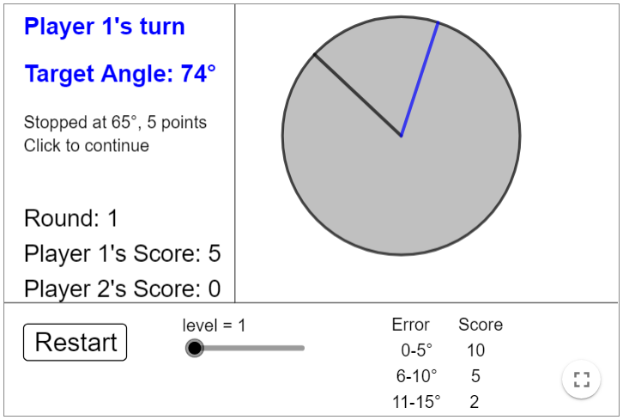

If you stop the rotating arm within 5° of the target, you score 10 points.
If you are between 6° and 10° of the angle, you score 5 points.
If you are between 11° and 15° of the angle, you score 2 points.

Player 1’s angle was 65°, which is 9° away from the target of 74°, so they scored 5 points.

Take it in turns to estimate ten angles.
Can you score more than 50 points?

After you have played some rounds, you might like to discuss why you find some angles easier to estimate than others.

