Some treasure has been hidden, and it’s your job to find it!

If you are playing online, every time you try to guess where the treasure is, the computer will tell you how far from the treasure you are.

This is what it might look like after your first guess.

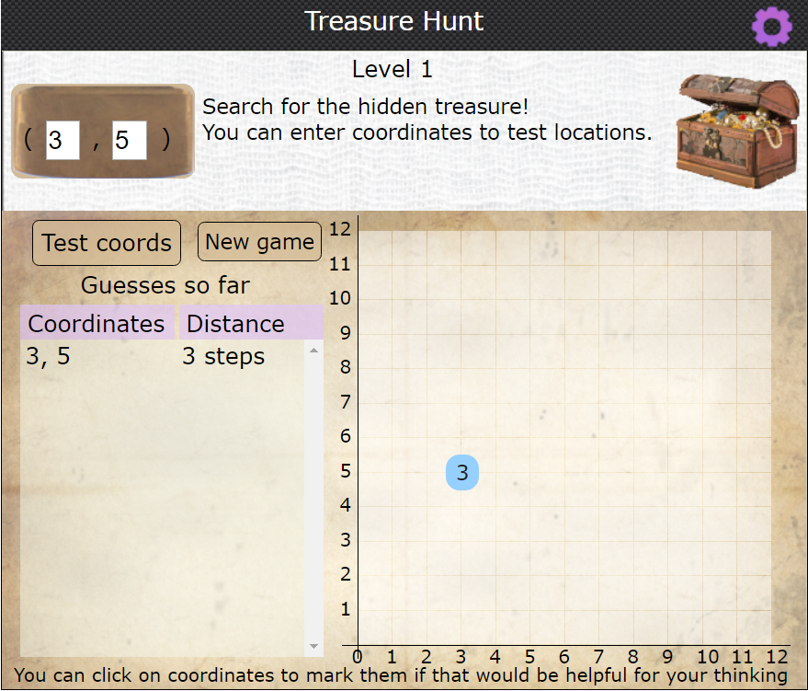

The first guess was (3, 5). The blue dot tells us that this is three steps away from the treasure.

So it could be three steps to the right at (6, 5)
Or it could be three steps up at (3, 8)
Or it could be two steps left and one step down at (1, 4)…

You can keep choosing coordinates to narrow down your search, until you find the treasure!

You could play online, or print out some grids and play with paper and pencil. Take it in turns to choose a secret place to hide your treasure, and then give clues to your partner!

How many guesses do you need to find the treasure?
Have you got a strategy for finding it without needing lots of guesses?

