Age 14+ Level
Worksheet 1
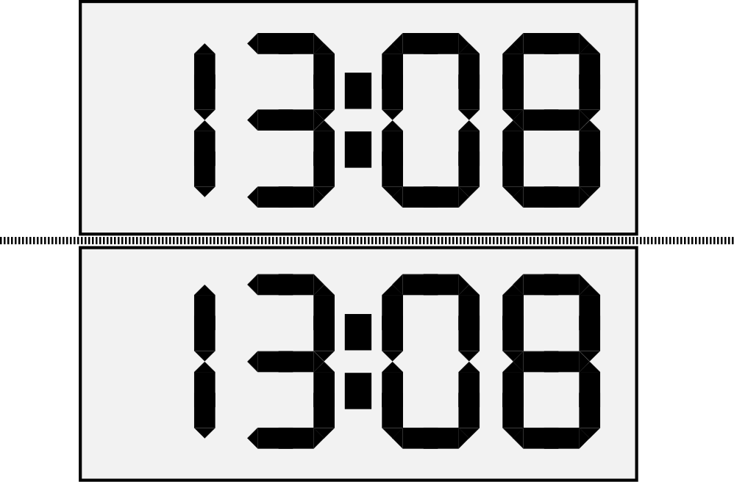
- Back in Time
Beatrix has a 24-hour digital clock on a glass table-top next to her desk.
When she looked at the clock at 13:08, she noticed that the reflected display also read 13:08, as shown.

How many times in a 24-hour period do the display and its reflection give the same time?

- Similar Perimeter
The lengths of the sides of a triangle A are 3, 4, and 6.
Triangle B is similar to triangle A.
One of the sides of triangle B has length 12.
What are the possible perimeters that triangle B could have?

- Rotation and Area
A has coordinates (4,4) and B is obtained by rotating A about the origin O through an angle of 135º anti-clockwise.
Calculate the area of triangle AOB.
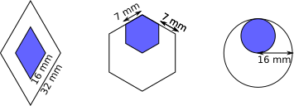
- Pendants
These designs are going to be made into pendants.

The diamond shape is a rhombus, the hexagon is regular, and the radius of the large circle is 16mm long. For each pendant, the blue shape is a smaller version of the whole pendant.

What proportion of each pendant will be blue?
- Climbing Ropes
Climbers use ropes of different diameters.
A 50m rope which is 9mm in diameter weighs about 2.7kg.
Roughly what would a 100m rope of the same material, but of diameter 11mm weigh?

