Age 11+ Level
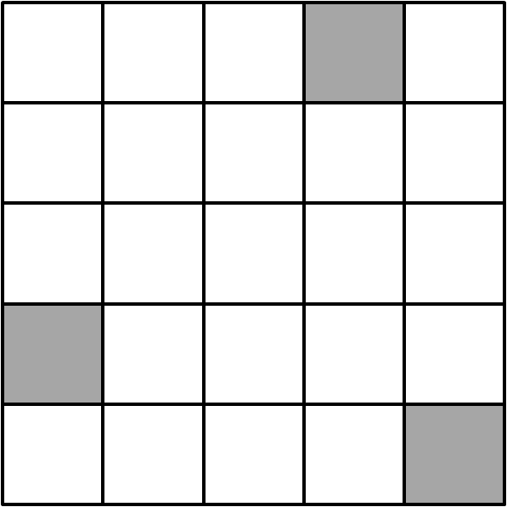
Worksheet 1

- Doubly Symmetric
What is the smallest number of additional squares that must be shaded so that this figure has at least one line of symmetry and rotational symmetry of order 2?

- Reflected Back
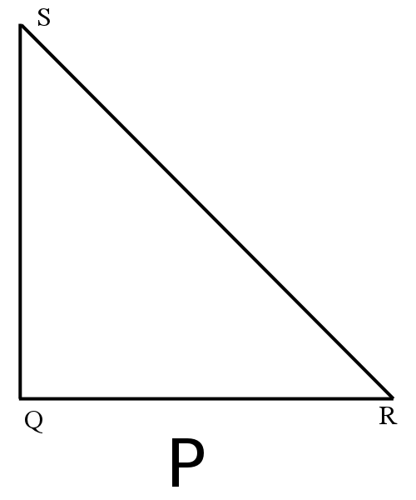
Triangle QRS is both isosceles and right-angled.
The letter P in the diagram is reflected in the line QR.
The image of this first reflection is then reflected in the line QS. The image of this second reflection is then reflected in the line RS.
Draw a diagram showing triangle QRS and the image of P after all three reflections.
- Reading from Behind
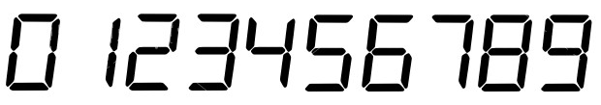
The ten digits of a digital clock are shown below:
I have a 12-hour digital clock which shows the time, using four digits, on a piece of glass, so it can be seen from both sides.
At what time between 3 o'clock and 10 o'clock does the time look the same from both sides?
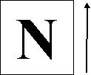
- Turning N Over
A square card printed with the letter N is held horizontally, as shown in the diagram, where the arrow indicates the direction of North.

The card is turned over by rotating it through $180°$about an axis running from East to West, and then turned over by rotating it through $180°$about an axis runnning from North-East to South West.
How does the diagram now look to a person facing North?
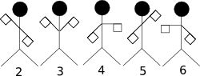
- Semaphore
I am standing behind five pupils who are signalling a five-digit number to someone on the opposite side of the playground.
From where I am standing the number looks like 23456.
What number is actually being signalled?

