Age 11+ Level
Worksheet 1
- Potatoes
Looking in at the greengrocer's window it said

When I went inside and looked from the other side, what did I see?

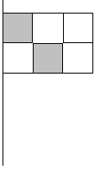
- Flag-tastic
A picture of a flag is to be completed by shading two squares that do not share an edge.
The diagram shows one way in which this can be done.

How many different possible completed pictures are there (including the one shown)?

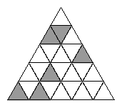
- Symmetriangle
The figure shows an equilateral triangle divided into small equilateral triangles, all equal.

What is the lowest number of small triangles which must now be shaded to produce a figure which has a line of symmetry?


- Grid Without Lines
The diagram shows nine points in a square array.

What is the smallest number of points that need to be removed in order that no three of the remaining points are in a straight line?

- Peri the Winkle
Peri the winkle starts at the origin $\left(0,0\right)$and slithers anticlockwise around a semicircle with centre $\left(4,0\right).$Peri then slides anticlockwise around a second semicircle with centre $\left(6,0\right)$, and finally clockwise around a third semicircle with centre $\left(3,0\right)$.
Where does Peri end this expedition?

