Age 11+ Level
Worksheet 1 – Solutions
- Potatoes
nrich.maths.org/6249/solution

- Flag-tastic
There are 8 different possible pictures.
If the squares are numbered 1 to 6, the possible pairings are:
1 | 3 | 5
2 | 4 | 6
1 and 4 2 and 5
1 and 5 2 and 6
1 and 6 3 and 6
2 and 3 4 and 5
nrich.maths.org/5010/solution

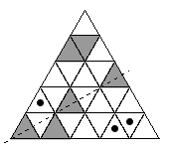
- Symmetriangle
The lowest number of small triangles which
must be shaded is 3

nrich.maths.org/2518/solution


- Grid Without Lines
Remove the three points along either diagonal:
nrich.maths.org/7134/solution

- Peri the Winkle
Peri will end the journey at (2,0)
nrich.maths.org/10127/solution

Age 11+ Level
Worksheet 1 – Solutions

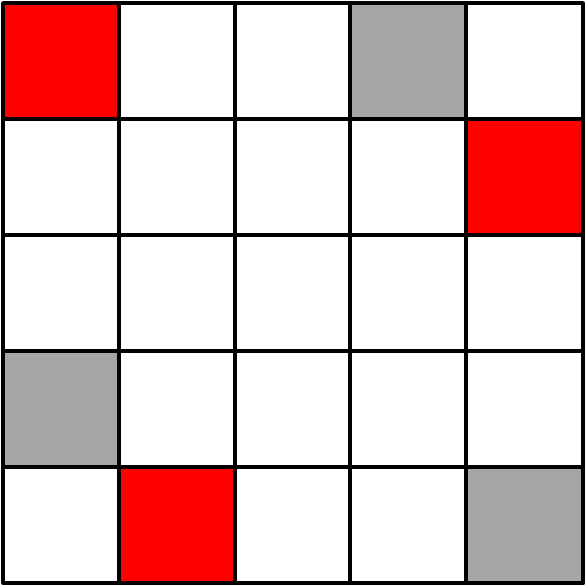
- Doubly Symmetric
The minimum number of extra squares
that need to be shaded is 3

nrich.maths.org/11634/solution

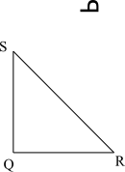
- Reflected Back
The final image should look
like this:

nrich.maths.org/10166/solution

- Reading from Behind
The time will look the same from both sides at 05:20
nrich.maths.org/7175/solution

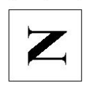
- Turning N Over
The diagram will end up
looking like this:
nrich.maths.org/2870/solution
- Semaphore
The number actually signalled is 42635
nrich.maths.org/6264/solution

Age 14+ Level
Worksheet 1 – Solutions

- Back in Time
The display and its reflection give the same time on 96 occasions
nrich.maths.org/10177/solution

- Similar Perimeter
The possible perimeters are 26, 39, and 52
nrich.maths.org/13777/solution

- Rotation and Area
The area of the triangle is $8\sqrt{2}$
nrich.maths.org/13393/solution

- Pendants
Exactly $\frac{1}{4}$ of each pendant will be blue
nrich.maths.org/12965/solution

- Climbing Ropes
The approximate weight of the rope will be 8.1kg
nrich.maths.org/13694/solution

