Age 11+ Level
Worksheet 1

- Farthest Fraction
$\frac{7}{15}$ is the largest
nrich.maths.org/2452/solution
- Smashing Time
3 cups are without saucers
nrich.maths.org/2454/solution

- Better Spelling
She need to take 4 more tests
nrich.maths.org/6769/solution
- Bouncing Ball
It bounces to a height of 27cm
nrich.maths.org/12828/solution

- Multiplication Magic Square
$r+s= \frac{1}{2}+ \frac{1}{16}= \frac{9}{16}$
nrich.maths.org/10180/solution

- Percentage Mad
£1.20
nrich.maths.org/2877/solution

Age 11+ Level
Worksheet 2

- Tommy’s Tankard
160ml
nrich.maths.org/11681/solution

- Ordering Fractions
$$\frac{3}{2} \frac{5}{3} \frac{7}{4} \frac{9}{5} \frac{11}{6}$$nrich.maths.org/10142/solution

- Talulah’s Tulips
$\frac{15}{60}=\frac{1}{4}$ of the tulips are white
nrich.maths.org/11684/solution

- Valuable Percentages
c) 30% of 30, has the greatest value
nrich.maths.org/6786/solution

- Information Display
$\frac{1}{2}$ of the dots in the array are illuminated
nrich.maths.org/5750/solution

Age 11+ Level
Worksheet 1

- Charlie’s Money
He started off with £36
nrich.maths.org/13541/solution

- Pride of Place
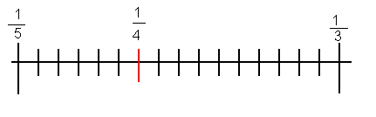
nrich.maths.org/7141/solution

- Three Blind Mice
$\frac{8}{27}$ of the cheese is left
nrich.maths.org/9767/solution

- Halfway
$\frac{1}{15}$ is halfway
nrich.maths.org/6787/solution

- Magical Products
$$3$$ | $$\frac{1}{6}$$ | $$2$$
$$\frac{2}{3}$$ | $$1$$ | $$\frac{3}{2}$$
$$\frac{1}{2}$$ | $$6$$ | $$\frac{1}{3}$$

nrich.maths.org/7189/solution

Age 11+ Level
Worksheet 1

- Too Close to Call
From smallest to largest:

$$\frac{111110}{111111} \frac{333331}{333334} \frac{222221}{222223}$$
nrich.maths.org/2451/solution

- Tricky Fractions
$x=341$
nrich.maths.org/12878/solution

- Peanut Harvest
$\frac{1}{5}$ of the original harvest was left
nrich.maths.org/12586/solution

- Slightly Outnumbered
The smallest possible number of girls is 5 (in a class of 11 pupils)
nrich.maths.org/6757/solution

- How Shady?
$\frac{127}{256}$ of the largest triangle is shaded
nrich.maths.org/13239/solution

Age 14+ Level
Worksheet 1

- A Drink of Water
Rachel drinks 450ml
nrich.maths.org/10191/solution
- Entrance Exam
There are 25 questions on the test
nrich.maths.org/12610/solution

- Petrol Station
Andrea puts $18\frac{1}{3}$ litres of petrol in the tank
nrich.maths.org/7163/solution

- The Grand Old Duke of York
$76.5 \%$ of the army remained
nrich.maths.org/11724/solution
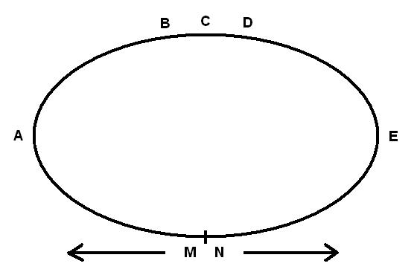
- Meeting Point
They will meet at A
nrich.maths.org/6200/solution

Age 14+ Level
Worksheet 2

- Porridge
5% of the porridge mixture is wheat bran
nrich.maths.org/5032/solution

- Test Scores
Alex got 19 marks
nrich.maths.org/11620/solution

- Tennis Club
The ratio of boys to girls is 3:1
nrich.maths.org/4738/solution

- Baby Boom
C showed the largest percentage increase nrich.maths.org/2498/solution

- Pied Piper
He caught 3736 rats
nrich.maths.org/5011/solution

Age 14+ Level
Worksheet 1

- 2011 Digits
They add to 9046
nrich.maths.org/10106/solution

- Recurring Mean
The mean is $1\frac{2}{3}$ (or $1.\dot{6}$ )
nrich.maths.org/5702/solution
- Pineapple Juice
30% of the orange drink was juice
nrich.maths.org/13675/solution

- Bargain
The total reduction was 57.5% of the original price
nrich.maths.org/9768/solution

- Washing-up
$\frac{1}{2}$ of customers now buy Kleenz
nrich.maths.org/11655/solution

- Fractions of 1000
$$100$$nrich.maths.org/7145/solution

Age 14+ Level
Worksheet 2

- Solitaire
I need to play 10 extra games
nrich.maths.org/10141/solution

- Breakfast Time
$\frac{81}{256}$ of the porridge is left
nrich.maths.org/11675/solution
- Percentage of a Quarter
80%
nrich.maths.org/11729/solution
- Percentage Swap
2007
nrich.maths.org/5700/solution
- Itchy's Fleas
At least 990 000 fleas will be removed
nrich.maths.org/11695/solution

- Coal Truck
75% of the total mass is coal
nrich.maths.org/13642/solution
- Percentage Unchanged
The width is decreased by $9\frac{1}{11}\%$ (or $9.\dot{0}\dot{9} \%$ )
nrich.maths.org/515/solution

Age 14+ Level
Worksheet 1

- Squeezed In
$x=92$
nrich.maths.org/11701/solution
- Elephants and Geese
81 wild geese
nrich.maths.org/12927/solution

- Antiques Roadshow
2 999 900% profit is approximately 3 000 000% profit nrich.maths.org/5704/solution

- Producing an Integer
It is an integer when $n$ is odd
nrich.maths.org/2216/solution

- The Property Market
Overall he made a loss of £21000
nrich.maths.org/13029/solution

