Age 14+ Level
Worksheet 1

- 3-sided
Jack's teacher asked him to draw a triangle of area $7{\text{cm}}^{2}$.
Two sides are to be of length $6\text{cm}$ and $8\text{cm}$.
How many possibilities are there for the length of the third side of the triangle?

- Pink and White
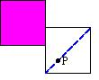
A square of side 8cm, is painted pink and fixed to a table.
An identical square, painted white, is placed on the table alongside the pink square, and has a point P marked one quarter of the way along the diagonal as shown.
If the white square slides once around the pink square, keeping the same orientation and always remaining in contact with the pink square, through what distance does P move?
- Either Side
A wire in the shape of an equilateral triangle with sides of length 9 cm is placed on a flat piece of paper.
Imagine rolling a circular disc of radius 1cm around the inside of the wire. What path would the centre of the disc traced out?
What if you rolled the disc around the outside of the wire?

- Snail’s pace
A snail is at one corner of the top face of a cube with side length 1m. The snail can crawl at a speed of 1m per hour.
What proportion of the cube's surface is made up of points which the snail could reach within one hour?
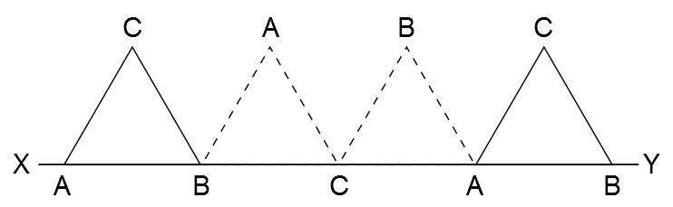
- Triangular wheel
The equilateral triangle ABC has sides of length 1 unit and AB lies on the line XY.
The triangle is rotated clockwise around B until BC lies on the line XY. It is then rotated similarly around C and then about A as shown in the diagram.
What is the length of the path traced out by point C during this sequence of rotations?

