Age 14+ Level
Worksheet 1 – Solutions

- 3-sided
There are 2 possibilities for the length of the third side
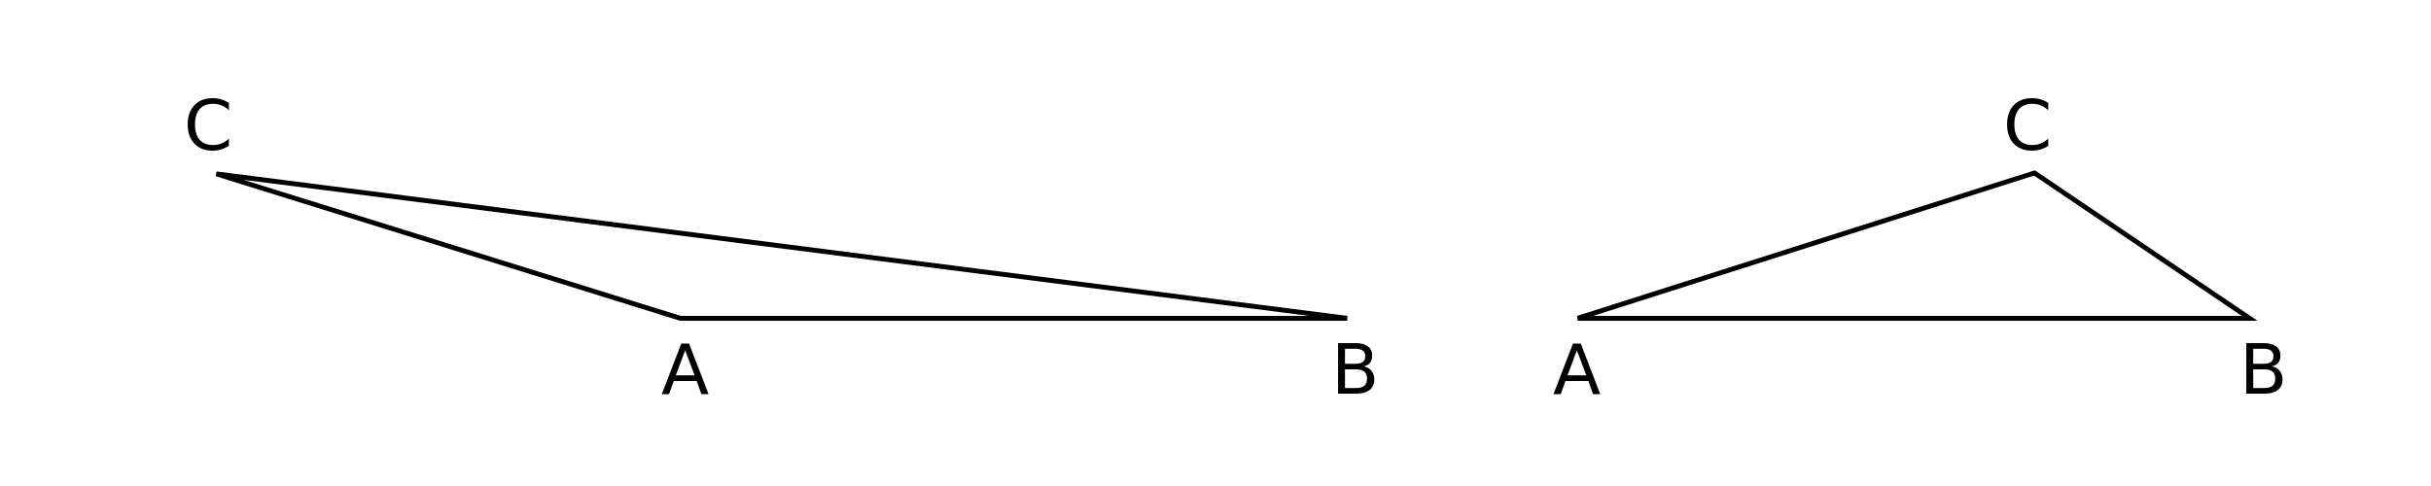
nrich.maths.org/10157/solution

- Pink and White
P moves through a distance of 64cm
nrich.maths.org/2902/solution

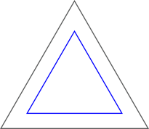
- Either Side
The path made by rolling the disc along the inside of the triangle is another equilateral triangle.
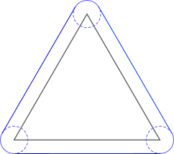

The path made by rolling the disc around the outside is shown on the left.
nrich.maths.org/2409/solution

- Snail’s Pace
The proportion of the cube’s face which the snail could reach is $\frac{π}{8}$
nrich.maths.org/9765/solution

- Triangular wheel
The total length of the path traced by C is $\frac{4π}{3}$
nrich.maths.org/10132/solution

