Age 14+ Level
Worksheet 3

- Algebraic Average
The mean of three numbers x, y and z is x.
What is the mean of y and z?

- Maximum Mean
The mode of nine numbers between 0 and 100 is 12, the median is 41, and the range is 75.
What is the largest possible value of the mean?

- Sample
Here are three populations:

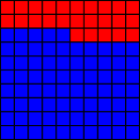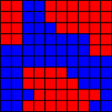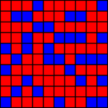

An opportunity sample, a systematic sample and a random sample was taken from each.

Can you match the samples to the populations?

Opportunity samples (a convenient block of 9 squares was chosen):

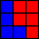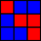

Systematic samples (every 11th square was chosen to give a sample size of 9):

Random samples (9 squares were chosen at random):

