Age 14+ Level
Worksheet 2
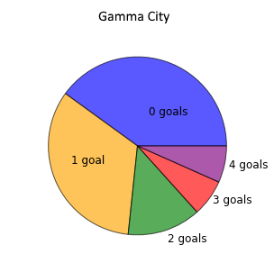
- Gamma City
Gamma City have played fifteen games in their league.
The pie chart shows how many goals they scored in each of their matches.
Can you find the mode and median number of goals scored by Gamma City?
- Mean Median
The mean weight of five children is 45 kg.

The mean weight of the lightest three children is 42 kg and the mean weight of the heaviest three children is 49 kg.
What is the median weight of the children in kg?

- Acceptance Rate
The mean number of students accepted by a school in the four years 2007 to 2010 was 325.

The mean number of students accepted by the school in the five years 2007 to 2011 was 4% higher.
How many students did this school accept in 2011?

- A Mean Calculation
Can you work out the mean of this set of numbers without using a calculator?
97 97 98 99 99 99 100 100 101 101 103 104 104 105

