Age 14+ Level
Worksheet 1

- Average Discovery
The mean, median and mode of five numbers are all the same.
If four of the numbers are 7, 7, 5 and 7, what is the fifth number?

- Partial Means
The mean of a sequence of 64 numbers is 64.
The mean of the first 36 numbers is 36.

What is the mean of the last 28 numbers?

- Mean Balance
The mean of the set of numbers 8, 4, 5, 4, ,  and 6 is 6.
If another is added to the set, then the mean is still 6.
What numbers do and represent?
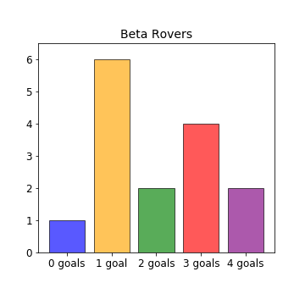

- Beta Rovers
Beta Rovers have played fifteen games in their league.
The bar chart shows how many goals they scored in each of their matches.
Can you find the mode and median number of goals scored by Beta Rovers?
- Ladybird Football Team
The six-member squad for the Ladybirds five-a-side team consists of a 2-spot ladybird, a 10-spot, a 14-spot, an 18-spot, a 24-spot and a pine ladybird (as reserve).

The average number of spots for members of the squad is 12.
How many spots does the pine ladybird have?

