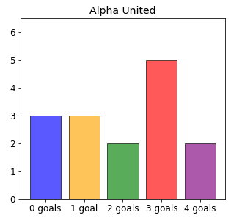
Age 11+ Level
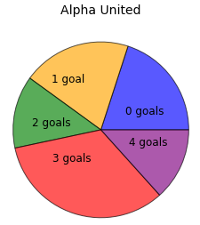
Worksheet 2
- Alpha United
Alpha United have played fifteen games in their league.
The bar chart and pie chart show how many goals they scored in each of their matches.
Can you find the mode and median number of goals scored by Alpha United?

- Average Temperature
The average temperature in 6 European cities is 5º Celsius.
What is the new average temperature, if two more cities, with temperatures of 12º Celsius and −6º Celsius, are added to the list?

- French Test
The first four students to take a test get an average of 4 marks.
The next six students to take the test get an average of 6 marks.
What is the average for all 10 students?
- Sevens
Sophie has to choose seven different positive whole numbers whose mean is 7. What is the largest possible number that she could choose as one of the seven numbers?

- Bat Wings
Here is a table of information about the wingspan of bats. Unfortunately, two entries are missing from the table.
Student | Data Set (Wingspans in cm) |  |  |  |  |  | Mean (cm)
A | 13 | - | 16 | 12 | 10 | 15 | 13
B | 13 | 16 | - | 13
Student A collected 6 measurements and worked out that their mean was 13cm. Student B collected 4 measurements.
The overall mean of the combined data was 13.4cm.

Can you work out what the two missing values are?

