Age 11+ Level
Worksheet 1
- Kate’s Date
The mean mass of five giant dates was 50g. Kate ate one and the mean mass of the four remaining dates was 40g.

What was the mass of the date that Kate ate?
- Choose the Mean
Find the 4 numbers which have a mean of 7, a median of 8 and a
mode of 9.

- Rugby and Ballet
The total mass of five rugby players is 425kg and the mean mass of ten ballet dancers is 40kg.

What is the average mass of all fifteen people?

- Range of Averages
Find the 4 numbers which have a mode of 12, a median of 14 and a range of 10.

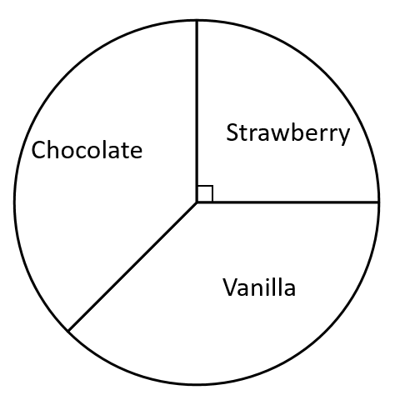
- Ice cream Pie
An ice cream stall sells vanilla, strawberry and chocolate ice creams.
The pie chart illustrates the sales of ice cream today.
The number of vanilla and the number of chocolate
ice creams sold were the same.
The stall sold 60 strawberry ice creams.
How many chocolate ice creams were sold?
- Balancing the Books
A tourist attraction, which opens every day, needs 30 000 visitors per day on average to break even.
Last week there were 120 000 visitors.
What is the number of visitors needed this week to break even over the two-week period?

