Age 11+ Level
Worksheet 1

- Monkey Puzzle
Three monkeys Barry, Harry and Larry met for tea in their favourite cafe, taking off their hats as they arrived. When they left, they each put on one of the hats at random.
What is the probability that none of them left wearing the same hat as when they arrived?

- Clubs
At Kaynem Daly High School, the Maths Club has 15 members and the Science Club has 12.
If a total of 13 students belong to only one of the two clubs, how many belong to both clubs?

- School Dinners
Our school dinners offer the same basic choice each day:
Starter: soup or salad
Main course: pasta, fishcakes, pizza, burger or curry
Dessert: crumble, cake or fruit salad

I change my choice for each course every day, trying each option in turn, going back to soup after salad, to pasta after curry and crumble after fruit salad. Today, I shall sit down to soup, pasta and crumble.
How many school dinners will I have eaten before I next sit down to the same combination again?

- Pieces of Eight
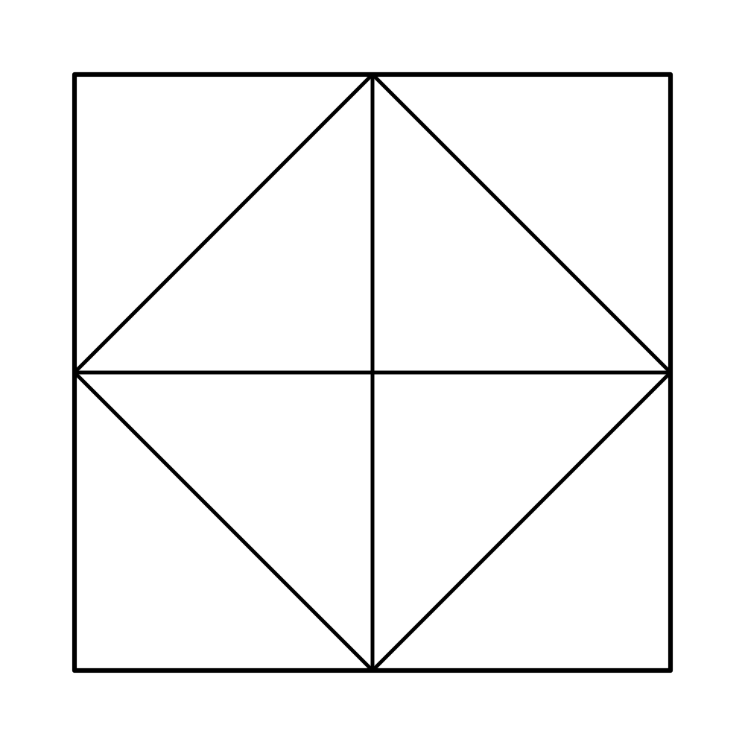
A square is divided into eight congruent triangles.

Two of these triangles are selected at random and shaded black.

What is the probability that the resulting figure has at least one line of symmetry?

