Age 11+ Level
Worksheet 1
- Would You Like a Jelly Baby?
In Tom's pocket there are 8 watermelon jelly babies, 4 vanilla jelly babies and 4 butter popcorn jelly babies.

What is the smallest number of jelly babies he must take out of his pocket to be certain that he takes at least one of each flavour?

- Strange Dice

An unusual die has its six faces labelled 1, 2, 3, 5, 7, 9.
If two such dice are rolled, and the numbers rolled added together, then how many different sums are possible?
Can you say which sums are most likely?

- Satnav Dilemma
How many different routes are there from S to T
which do not go through either of the points U and V
more than once?

- Birthday Party
You are told that 30 pupils have 25 different birthdays between them.

What is the largest number of these pupils who could share the same birthday?
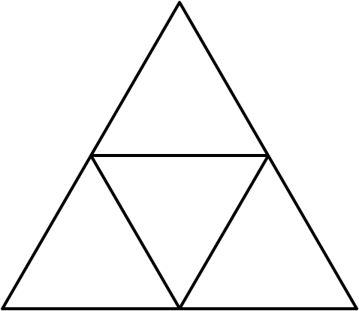
- Half and Half
The large equilateral triangle is fixed in position.

Two of the small equilateral triangles are to be painted black and the other two are to be painted white.
In how many ways can this be done?

