Age 11+ Level
Worksheet 1 – Solutions
- Would You Like a Jelly Baby?
He must take 13 jelly babies
nrich.maths.org/10105/solution

- Strange Dice
There are 14 different possible totals:
2, 3, 4, 5, 6, 7, 8, 9, 10, 11, 12, 14, 16 and 18.
10 is the most likely sum
nrich.maths.org/13695/solution

- Satnav Dilemma
There are 18 different routes
nrich.maths.org/2411/solution

- Birthday Party
The largest number of pupils who could share a birthday is 6
nrich.maths.org/4999/solution

- Half and Half
It can be done in 6 ways

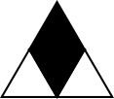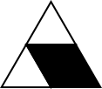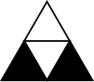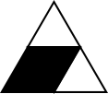

nrich.maths.org/11670/solution

Age 11+ Level
Worksheet 1 – Solutions

- Monkey Puzzle
The probability is $\frac{2}{6}=\frac{1}{3}$

nrich.maths.org/9434/solution

- Clubs
7 students belong to both clubs
nrich.maths.org/13684/solution

- School Dinners
I will have eaten 30 meals before I repeat the initial combination
nrich.maths.org/6223/solution

- Pieces of Eight
The probability is $\frac{5}{7}$

nrich.maths.org/10144/solution

Age 11+ Level
Worksheet 1 – Solutions

- Rain
5 days had no rain
nrich.maths.org/13643/solution

- Almost Constant Digits
There are 64 numbers
nrich.maths.org/7140/solution

- Perfect Score
At least 30 children answered all the questions correctly
nrich.maths.org/12628/solution

- Nine or Ten?
A total score of 10 is more likely
nrich.maths.org/639/solution

- Counting Socks
She must take 7 socks to be sure to have a pair without holes
nrich.maths.org/12623/solution

