Triangle Transformations

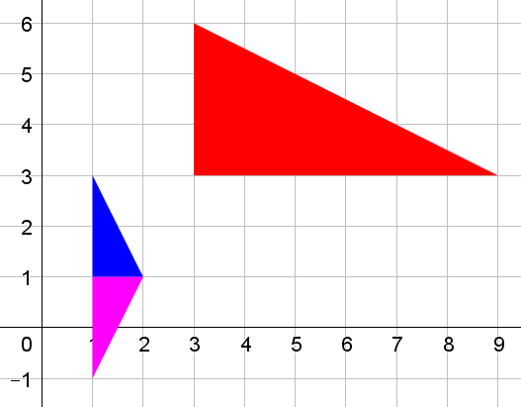
I drew the blue triangle with vertices at (1,1), (1,3) and (2,1).
Then I performed three transformations, one after the other, and ended up with the red triangle whose vertices are at (3,3), (9,3) and (3,6).
Finally I performed three more transformations, and ended up with the pink triangle whose vertices are at (1,1), (1,-1), and (2,1).

The transformations I performed were all chosen from the set of cards below:
Rotate 90° clockwise  around (0,0) | Rotate 90° anticlockwise around (0,0) | Rotate 180° around (0,0)
Reflect in the line x = 0 | Reflect in the line y = 0 | Reflect in the line y = x
Reflect in the line y = -x | Enlarge, scale factor 3  centre of enlargement (0,0) | Enlarge, scale factor $\frac{1}{3}$ centre of enlargement (0,0)
Enlarge, scale factor 2  centre of enlargement (0,0) | Enlarge, scale factor $\frac{1}{2}$  centre of enlargement (0,0) | Translate by the vector $\left(\begin{matrix}2 \\ 0\end{matrix}\right)$
Translate by the vector $\left(\begin{matrix}0 \\ 2\end{matrix}\right)$ | Translate by the vector $\left(\begin{matrix}-2 \\ 0\end{matrix}\right)$ | Translate by the vector $\left(\begin{matrix}0 \\ -2\end{matrix}\right)$

Can you find a set of three transformations that I could have performed to get from the blue triangle to the red triangle?
Can you find a set of three transformations that I could have performed to get from the red triangle to the pink triangle?
Can you find a set of three transformations that I could perform to get from the blue triangle to the pink triangle?
Can you find more than one set of three transformations for any of these?
Can you get from one triangle to another using just two transformations?

Create a triangle transformation of your own using three or more cards of your choice. Write down the coordinates of the vertices of your first and last triangles, and give them to a friend to see if they can figure out which transformation cards you used.

Triangle Transformations
Teachers’ Resources

Why do this problem?
This problem invites students to explore the effects of combining multiple transformations. By classifying the effects of different transformations, students can begin to gain insights into what happens when we combine multiple transformations, and make conjectures about which combinations of transformation might be equivalent.
Possible approach
Invite students to look at the blue, red and pink triangles. What can they say about how we might have got from one to another? Allow some time for discussion – they might notice that the red triangle is three times as big as the blue one, and that it is in a different orientation, and that the pink triangle and the blue triangle are mirror images of each other.
Then share the fifteen transformation cards from the Resource Sheet so that students can cut them out and choose different combinations of the transformations. Challenge students to find sets of three transformations which map each triangle onto the others.
Bring the class together and share what they have found. Take time to discuss that there are different ways to achieve the same overall result. Invite students to suggest ways of getting from one triangle to the others using fewer or more transformations. This could lead to discussions of how some of the transformations are inverses of each other, and some are self-inverse.
Finally, students could create their own chains of transformations to challenge each other.
Key questions
What clues are there about which transformations might have been used?
How does the triangle change if I reflect it? Or rotate it? Or enlarge it?
If I know how to get from the one triangle to another, how can I work out how to get back?
Possible support
Students may find it useful to draw out the triangles on tracing paper to help them perform the transformations.
You could also relax the restriction of using exactly three transformations.
Possible extension
Invite students to explore how the order in which transformations are performed affects the final outcome. Which combinations of transformations can be done in any order?

Triangle Transformations
Resource Sheet

Rotate 90°  clockwise  around (0,0) | Rotate 90° anticlockwise  around (0,0) | Rotate 180°  around (0,0)
Reflect in the line  x = 0 | Reflect in the line  y = 0 | Reflect in the line  y = x
Reflect in the line  y = -x | Enlarge, scale factor 3  centre of enlargement (0,0) | Enlarge, scale factor $\frac{1}{3}$ centre of enlargement (0,0)
Enlarge, scale factor 2  centre of enlargement (0,0) | Enlarge, scale factor $\frac{1}{2}$  centre of enlargement (0,0) | Translate by the vector $\left(\begin{matrix}2 \\ 0\end{matrix}\right)$
Translate by the vector $\left(\begin{matrix}0 \\ 2\end{matrix}\right)$ | Translate by the vector $\left(\begin{matrix}-2 \\ 0\end{matrix}\right)$ | Translate by the vector $\left(\begin{matrix}0 \\ -2\end{matrix}\right)$

