Quadrilateral Tiles

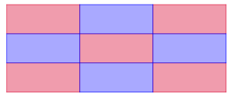
This picture shows how you can tile an area with rectangles.
They fit together with no gaps, because at each point, there are four 90° angles, which add up to 360°

A tiling pattern like this is called a tessellation.
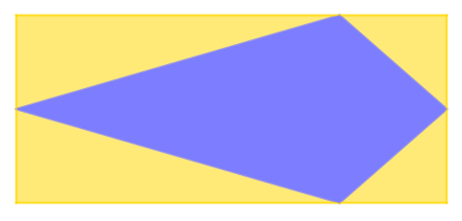
Here is a kite, with a rectangle drawn around it.
Draw a kite of your own, and a rectangle to surround it in the same way. Then tessellate your rectangle.
What do you notice?
Can you use this to prove that all kites tessellate?

Next, let’s investigate parallelograms.
Draw a parallelogram and cut it out, and then draw round it to make a tessellation pattern.
Can you use what you know about the angles in a parallelogram to prove that they fit together without leaving any gaps?
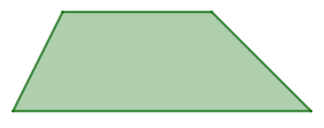
Here is a trapezium.
Can you find a way to put two identical trapezia together to make a parallelogram?
Can you use this to prove that trapezia will tessellate?

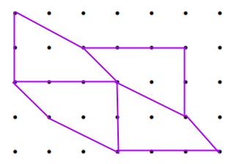
Can you find some irregular quadrilaterals that tessellate?
You might like to explore using a dotty grid.
Look for ways to arrange your quadrilaterals so that the four angles that meet at each point add up to 360°.

Are there any quadrilaterals that don’t tessellate?
Quadrilateral Tiles
Teachers’ Resources
Why do this problem?
This problem provides an engaging context in which students can apply their knowledge of the angle properties of quadrilaterals in order to produce convincing arguments and generalisations.
Possible approach
Students may need squared paper or dotty paper.
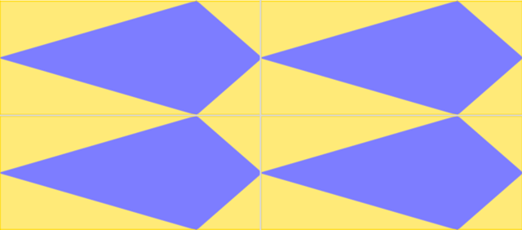
Start by sharing an image of tessellating rectangles and invite students to comment on what they notice. Draw attention to the fact that the angles around each point are all right angles and so we know that they add up to 360°.
Next, invite students to draw a kite and to surround their kite with a rectangle. Then ask them to draw a few copies of their rectangles in a tessellation pattern. Rotated kites should emerge.
Take some time to discuss the transformation needed to get from one kite to another, and how they know that the yellow and blue kites are the same.
Then invite students to explore parallelograms, and after that, trapezia.
Can they justify that all parallelograms and all trapezia will tessellate?
Finally, invite students to explore tessellations of irregular quadrilaterals on dotty grids. An image such as this one could be used to prompt a discussion about how to replicate the quadrilateral, and to draw attention to the angles that meet around each point.
Key questions
What do the angles in a quadrilateral add up to?
What do you know about angles in a parallelogram?
What happens if I rotate a quadrilateral 180° around the midpoint of one of its sides?
Possible support
Students could use dotty paper throughout, rather than just for the final part.
Possible extension
Challenge students to prove that all quadrilaterals, including concave ones, will tessellate.

