Mole and Goose
Here is a section of a horizontal number line:
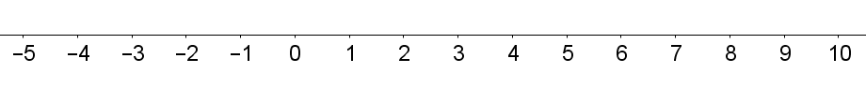
A goose walks along the number line and stops sometimes to lay an egg. She likes to space her eggs out equally. For example, she might lay her eggs at 2, 7, 12, 17, 22 …
A mole digs a tunnel below the number line. He likes to dig up to the surface every so often, to see how far he has gone. He always puts his head out at equally spaced intervals. For example, he might put his head out at 1, 4, 7, 10, 13 …
When the mole visits 7, he finds an egg there! Where else will the mole find an egg?

Choose a number where each animal starts, and decide how far each will travel on each step of the sequence. Does the mole find an egg? Does he find more than one?
Can you find some pairs of sequences where the mole finds more than one egg?
How can you predict how far apart the mole finds the eggs?
Can you find some pairs of sequences where the mole never finds an egg?
What is special about the size of the steps in these sequences?

Mole and Goose
Teachers’ Resources
Why do this problem?
This problem provides an engaging context in which to explore linear sequences and think about highest common factors and lowest common multiples.
Possible approach
Start by drawing a number line on the board and choose a random point for the goose to lay her first egg.
Explain to the class that the goose will travel along the number line laying eggs at regular intervals. Once an interval has been suggested, invite the class to work out the first few laying points.
Introduce the mole and choose a point (without an egg) for him to emerge. Explain that he will dig below the number line and come to the surface at regular intervals. Once an interval has been suggested, invite the class to work out the first few points at which he will emerge.
If we know the starting points, and the step sizes of the mole and the goose, how can we predict if the mole will find any eggs?
Invite students to explore what happens when they choose different starting points and step sizes. Encourage students to record their work so that they can share their observations, insights and discoveries.
Key questions
When the mole finds an egg, how can we work out where he will next find an egg?
What is special about the step sizes in sequences where the mole never finds an egg?
Possible support
Students could start by just exploring what happens when the goose and the mole start at the same point.
Possible extension
If we are given a sequence of points at which the mole finds an egg, how can we find the possible starting points and step sizes of the mole and the goose?

