Four Steps

I wonder where I can get to if I start at the origin (0, 0) and take four steps along the gridlines, going up, down, left or right…
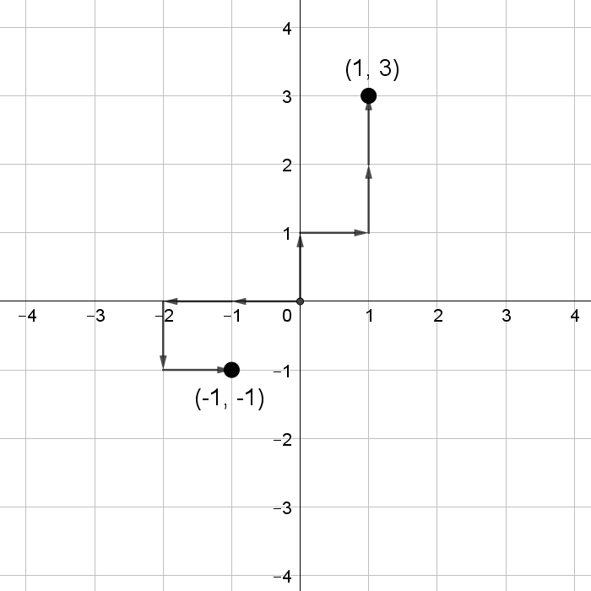
Here are two possible paths:

When I go “up, right, up, up”, I end at the point (1, 3).

When I go “left, left, down, right”, I end at the point (-1, -1).

Explore some other four-step paths, starting at the origin.

How many different points can I end up at?
What shape is made by the points that I can reach?
What is special about the coordinates of the points at which I can end up?
Are there any points that I can only reach in one way?
Explore the number of ways you can reach the points on the boundary.

Once you’ve explored four-step paths, you might like to explore five-step paths, or six-step paths, or…

Four Steps
Teachers’ Resources
Why do this problem?
This problem provides an engaging context in which to explore coordinates, and discover some surprising results.
Possible approach
Students will need squared paper.
Start by explaining the context and share the two examples presented in the problem.
Invite students to draw some other four-step paths, starting at the origin.
Encourage them to record the end points of their paths.
Once they have generated some examples, invite them to share what they’ve noticed and to suggest mathematical questions that they could explore. Some fruitful lines of enquiry are suggested in the problem.
Finish off by discussing students’ insights and discoveries. They may include explanations of why the total number of points that can be reached is always a square number, and/or observations that the number of ways to reach each point on the boundary can be calculated using Pascal’s Triangle.
Key questions
What shape is made by the points that I can reach?
What is special about the coordinates of the points at which I can end up?
Possible support
Students could start by considering the end points which can be reached in just two steps, before extending those paths to three steps and four steps.
Possible extension
Challenge students to find how many different points can be reached by taking n steps from the origin.

