Diamond Decimals
The Decimal Diamond on the right was generated from the diamond on the left.
Work out how the values in the squares were calculated.
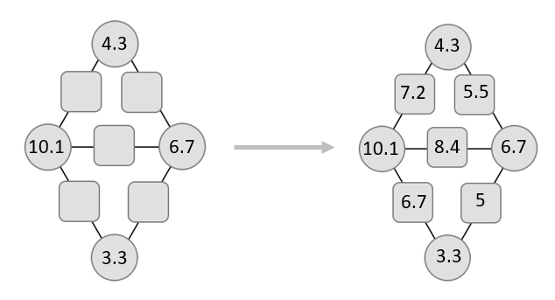
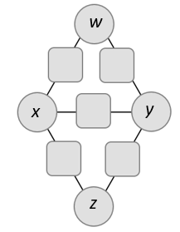
Now choose a value for the top circle w, and choose a decimal g, between 0 and 1, which will be the gap between the values, so that:
$$w + g=x \\ x + g=y \\ y + g=z$$
Work out the values that go in the five squares.
Try it a few times with different values for w and g.
What do you notice?
If someone told you the values they chose for w and g, can you find a quick way to work out the values in their squares?
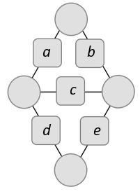
Now choose a number to go in the square marked a, and choose a decimal g, between 0 and 1, which will be the gap between the values, so that:
$$a+g=b \\ b+g=c \\ c+g=d \\ d+g=e$$
Can you work backwards to figure out what numbers need to go in the circles to make the Decimal Diamond complete?
Is it possible to complete a Decimal Diamond if you are only given two of the entries?
Diamond Decimals
Teachers’ Resources
Why do this problem?
In this problem, students can practise adding, subtracting and dividing decimals in a context that invites them to conjecture and generalise.
Possible approach
Show students the first Decimal Diamond.
Invite them to think for a moment about how the numbers in the squares were calculated.
Make sure everyone appreciates that the value in each square is the average of the values in the two adjacent circles.

Next, introduce an example of a Decimal Diamond where w, x, y and z form a sequence with a constant gap g between the terms.
Invite students to choose a few different values for w and g and work out the rest of the values in their decimal diamonds.
Once they have done a few examples, they should be ready to notice that the values in the five squares also form a sequence, and that the gap between the terms is half the original gap g.
Then set the inverse problem: given a sequence for the squares, can they work out the values that go in the circles?
Key questions
What is the relationship between the values in the squares and the values in the adjacent circles?
How does the sequence in the squares relate to the sequence in the circles?
How can you use this to predict all the values if you only know the values of w and g?
Possible support
Students could start by exploring examples where all of the numbers are whole numbers or multiples of 0.5
Possible extension
Challenge students to complete Decimal Diamonds when they are only given two of the entries. They may need to work algebraically to do this.

