Cutting Tablecloths

Imagine a square piece of cloth 1 metre by 1 metre that might be altered to make a tablecloth for a rectangular table.

I could cut off a strip 20% of the way along the square, rotate it, and attach it to the other edge to make a rectangle. There would be a little bit of cloth left over!

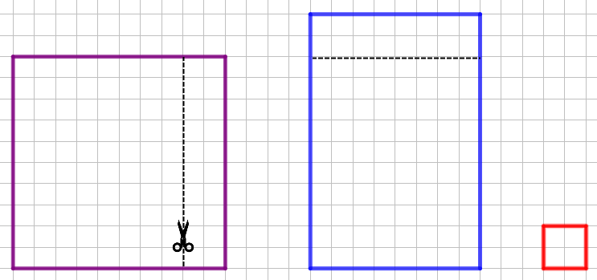

The purple square is the original tablecloth.
The blue rectangle is the new tablecloth.
The red piece shows the cloth that is left over.
What percentage of the original cloth has been used to make the new tablecloth?
Instead of cutting off a 20% strip, we could cut a 10% strip, or a 15% strip, or…
Choose some percentages to try out. For each example you try, think about the following questions:
What percentage of the original cloth would be used to make the new tablecloth?
What percentage of cloth is wasted in each case?

Is there a quick way to work out the percentage of cloth used and wasted, if you know what percentage strip was cut off?
If I wanted to make a rectangular tablecloth in this way, with an area of 75% of the original cloth, how big a strip would I need to cut?
If I wanted to make a rectangular tablecloth in this way, with an area 50% of the original cloth, how big a strip would I need to cut?

Cutting Tablecloths
Teachers’ Resources
Why do this problem?
This problem offers an interesting context in which students can practise working with percentages and critique the different approaches and representations that emerge. It also offers students an opportunity to use algebra to express the relationships they discover and make generalisations.
Possible approach
Introduce the context of making a rectangular tablecloth from a piece of fabric using one cut and one join, as shown in the diagram.
Invite students to work out the percentage of cloth that has been used to make the new rectangle when 20% is cut off as shown, and then share their methods for working it out.
Some students might work out the area of the blue rectangle and then express it as a percentage of the area of the purple rectangle. Others might work out the area of the red square as a percentage of the purple square, and subtract this from 100. This is a good opportunity invite students to critique the different methods.
Next, invite students to explore cutting off strips which are other percentages of the original. Challenge them to find a relationship between the percentage strip that is cut off and the percentage of the cloth that is used for the new tablecloth.
Finally, challenge students to work backwards and find out what percentage strip needs to be cut off to create a tablecloth that uses 75%, and then 50%, of the original cloth.
Key questions
What is the length of the new tablecloth? What is its width?
What will the dimensions of the new tablecloth be, when I cut off n% of the original square?
Possible support
Start by focussing on cuts which are multiples of 10%.
Encourage students to make a table so they can look for patterns in their results. It might be easier to work with the area of the leftover cloth rather than the area of the new rectangle.
Possible extension
Invite students to consider what might happen if they started with a 2m by 1m piece of cloth instead of a square.

