Clock Rectangles

Here is a clock face with 12 equally spaced points around a circle:
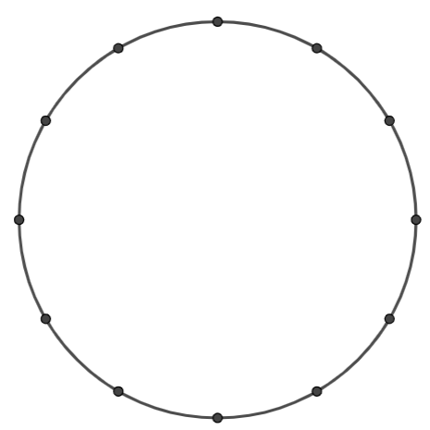

Can you find four points that join together to make a rectangle?
How do you know it is a rectangle?
Can you find more than one rectangle?
How many different rectangles is it possible to draw on a clock face?

Once you’ve explored rectangles on a clock face, here are some more questions you might like to explore:
What if a clock face only had eight equally spaced points around the edge?
How many rectangles can you find now?
What about a clock face with 18 equally spaced points?
Is there a way to predict the number of rectangles for a clock face with any number of equally spaced points?
What other quadrilaterals can you find on different clock faces?
Which of these is it possible to draw?
- Kite
- Parallelogram
- Rhombus
- Trapezium
Do your answers depend on the number of equally spaced points?

Clock Rectangles
Teachers’ Resources
Why do this problem?
This problem provides an interesting context in which to reason geometrically about the properties of quadrilaterals and circles.
Possible approach
Students will need copies of the Resource Sheet.
More circle templates can be found at https://nrich.maths.org/printable
Start by challenging students to draw a rectangle by joining four of the points on a 12 point circle.
Challenge them to provide convincing arguments to justify that their shape is a rectangle. They might mention symmetry (reflection and rotational), lengths of diagonals, angles, lengths of opposite sides, parallel lines.
Invite students to explore the number of possible rectangles that can be drawn on different clock faces. Challenge them to predict the number of rectangles that can be drawn on clock faces with any number of equally spaced points.
Finish off by discussing students’ insights and discoveries.
Key questions
How do you know that the angles are 90°?
How do you know that the opposite sides are parallel?
How do you know that the diagonals are of equal length?
Possible support
Students could start with the 8 point circle, and use a set-square, or the corner of a piece of paper, to look for points that can be joined to make right angles.
Possible extension
Challenge students to find which of these it is possible to draw on different clock faces:
- Kite
- Parallelogram
- Rhombus
- Trapezium

Clock Rectangles
Resource Sheet
8 point circles
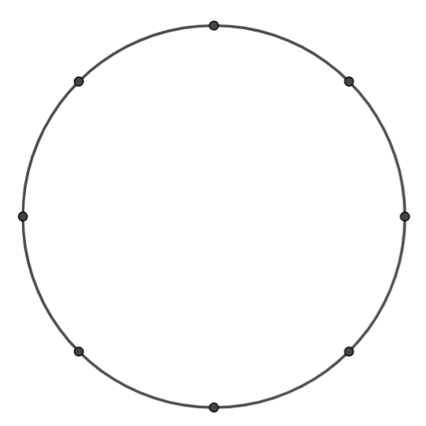
12 point circles
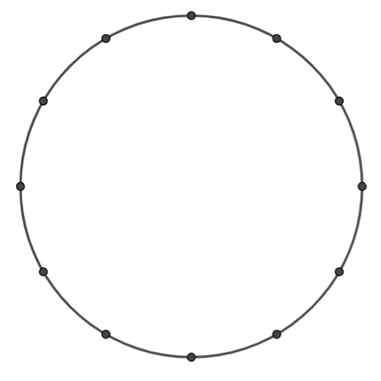
18 point circles
