Biggest Cuboid

Start with a 12cm by 12cm square of paper.
Draw six rectangles that can be cut out and fitted together to make a cuboid.
For example, these six rectangles could be joined to make this 2cm by 3cm by 5cm cuboid:

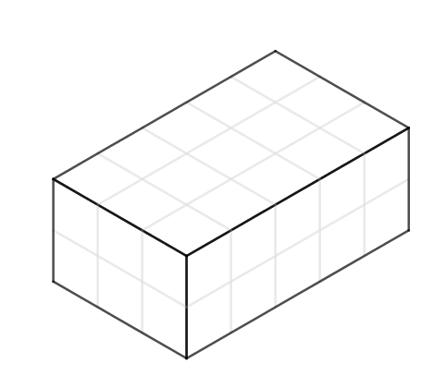
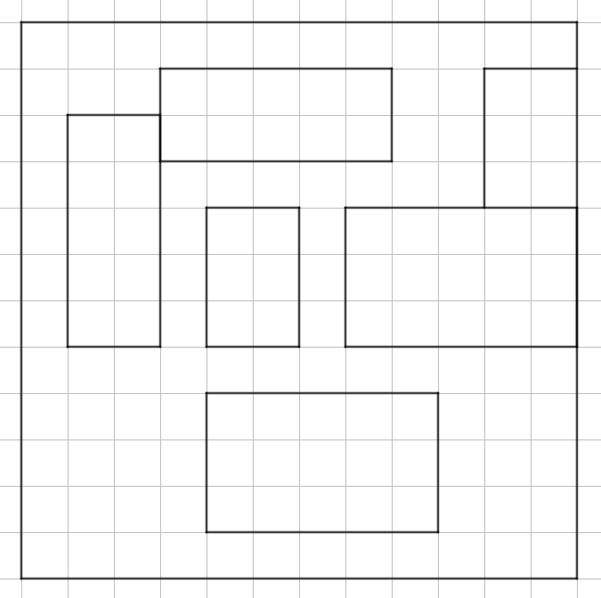

There are lots of gaps in between the rectangles, so perhaps we could have made a cuboid with a bigger surface area and a bigger volume.
Can you find a cuboid that uses more of the paper?
What is the volume of your cuboid?
What different volumes of cuboid can you make from a 12 by 12 square?
Can you find any cuboids that use the whole of the 12 by 12 square?
What is the biggest volume of cuboid you can make?

Biggest Cuboid
Teachers’ Resources
Why do this problem?
This task offers students the opportunity to apply their knowledge of volume and surface area while challenging them to improve upon their initial solutions as they try to find an optimal arrangement.
Possible approach
Students may need squared paper.
Show the diagram of the six rectangles and invite students to consider how the rectangles could be arranged to form a cuboid and what the dimensions of the cuboid would be.
Point out that there are a variety of different cuboids that could be made by cutting rectangles from a 12 by 12 square, and challenge students to find some examples.
As the lesson progresses, invite students to share the volumes of the cuboids they have found, and challenge them to find the maximum possible volume that can be made.
You could also invite them to try to make a cuboid with a surface area of exactly 144cm² (which uses all of the paper).
Key questions
If one of the rectangles has dimensions 3cm and 4cm, what must be true about the dimensions of the other rectangles?
How many different ways can you arrange six rectangles on the paper?
Possible support
Students could start with a smaller square of paper, such as 8cm by 8cm.
Possible extension
Students could investigate the largest volume of cuboid that can be made from rectangular paper of different dimensions, keeping one dimension fixed.
For example:
12cm by 2cm
12cm by 4cm
12cm by 6cm… and so on

