Each symbol has a numerical value. The total for the symbols is written at the end of each row and column.
Can you find the missing total that should go where the question mark has been put?

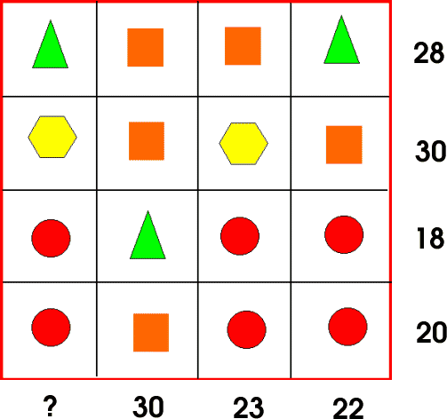

Can you find more than one way to do it?

