Age 14+ Level
Worksheet 1

- Diagonals
A square has 2 diagonals, a regular pentagon has 5 and a regular hexagon has 9.
How many diagonals does a regular icosagon (20 sides) have?

- Difference Sequence
The first term in a sequence is 2016 and the second term is 2017.
Every other term is given by the difference between the two terms before it. So, for example, the third term is the difference between 2016 and 2017, which is 1.
The $n$^{th} term is equal to 2000; what is the value of $n$?

- Trolley Park
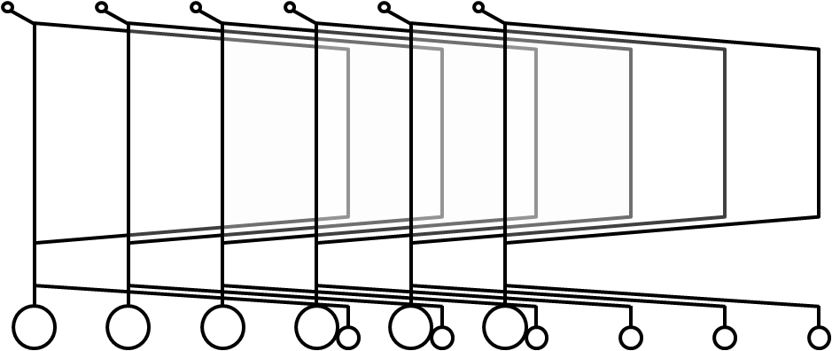
In a supermarket, there are two lines of tightly packed trolleys.
The first line has ten trolleys and is $2.9m$ long. The second line has twenty trolleys and is $4.9m$ long.
What is the length of one trolley, in m?

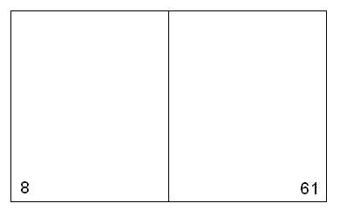
- Newspaper Sheets
Here is a sheet of a newspaper.
Each sheet has four pages.
How many sheets are there altogether?

- Alternating Sum
Given that the number 2008 is the correct answer to the calculation below, what is $n$?

$$1 –2+3 –4+5 –6+…+(n-2)-(n-1)+n$$

