Age 11+ Level
Worksheet 2

- How many Rectangles?
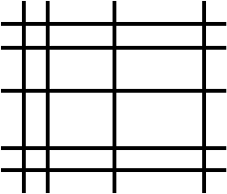
By drawing $9$ lines, $5$ horizontal and $4$ vertical, one can form $12$ small rectangles, as shown on the right.
What is the greatest possible number of small rectangles that one can form by drawing $15$ lines, either horizontal or vertical?

- Hexagon Line
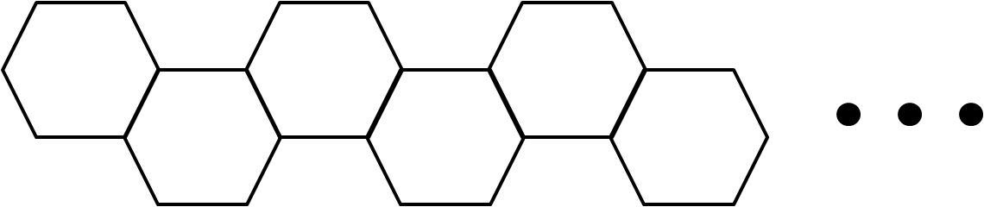
A shape consisting of a number of regular hexagons is made by continuing the pattern shown in the diagram, with each extra hexagon sharing one side with the preceding one.
Each hexagon has a side length of $1$cm.
How many hexagons are required for the perimeter of the whole shape to have length $1002$cm?

- Pattern Snake
The diagram below shows a pattern which repeats every 12 dots.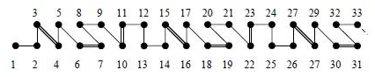
What does the piece between 2007 and 2011 look like?
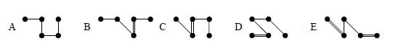
- Night Watchmen
Granny's watch gains 30 minutes every hour, whilst Grandpa's watch loses 30 minutes every hour. At midnight, they both set their watches to the correct time of 12 o’clock.
What is the correct time when their two watches next agree?

