Age 11+ Level
Worksheet 1

- Sliding Robot
A robot moves along the number line.
It starts at $0$, slides forward one unit (to $1$), slides backwards $2$ units (to $-1$), then forward $3$, back $4$, and so on.
It slides alternately forward and backwards, with each slide one unit longer than the previous one.
Where is the robot after $2011$ slides?

- Knockdown
Pegs numbered $1$ to $50$ are placed in order in a line, with number $1$ on the left. They are then knocked over, one at a time, following these rules:
- Starting with the first standing peg on the left, alternate pegs are knocked down, until the end of the row is reached.
- Each time the end of the row is reached, repeat the previous rule.
What is the number of the last peg to be knocked down?

- Square Grid
A square is split into a 100 by 100 square grid.
100 squares in the first row are shaded, 99 in the second row, 98 in the third row, and so on.
What fraction of the whole square is shaded?

- Tiled Floor
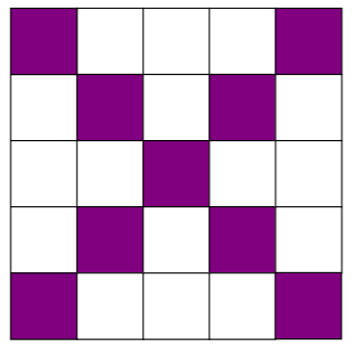
In Andrea's house, all floors are square, and covered with square tiles.
Tiles along the diagonal are purple, and the other tiles are white, as shown in the diagram.
There are 109 purple tiles on the square bathroom floor. How many tiles are there altogether on the bathroom floor?

