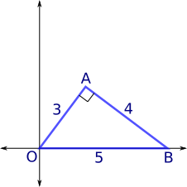
Age 14+ Level
Worksheet 1

- Triangular Slope
What is the gradient of OA?
What is the gradient of AB?

- Graph Triangles
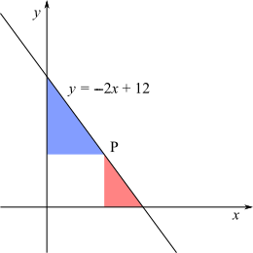
This is the graph of the line $y=-2x+12$.

Point P is on this line.

The ratio of the area of the red triangle to the area of the blue triangle is $1:4$.

Find the coordinates of point P.

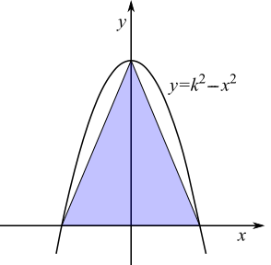
- Inside a Parabola
The points where the parabola $y=k^{2}- x^{2}$ crosses the coordinate axes are joined to form a triangle.

The area of the triangle is 64 square units.

What is the value of $k$?

- Closer to Home
Consider the graphs with equations $y=2x- 10$and $y=x- 6$.
Which comes closer to the origin?
Can you find the shortest distance between this line and the origin?
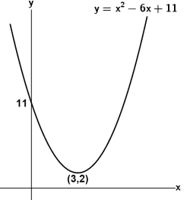
- Quadratic Rotation
The curve $y=x^{2}- 6x+11$is rotated through 180º about the origin.
What is the equation of the new curve?

