Age 11+ Level
Worksheet 1

- Bucket of Water
Lisa's bucket weighs 21 kg when full of water. After she pours out half the water from the bucket it weighs 12 kg.
What is the weight of the empty bucket?

- Paper Weight
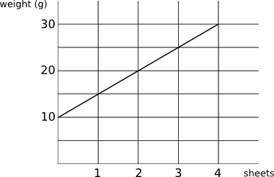
The graph shows how the weight of a letter (including the envelope) varies with the number of sheets of paper used.

What is the weight of a single sheet of paper?

- Circumference and Diameter
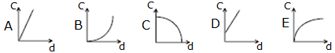
Which of the following could be the graph showing the circumference C of a circle in terms of its diameter d?

- Straight Line Spin
Draw a diagram which shows the graph of $y=x$ after it has been rotated $90°$ clockwise about the point $(1,1)$.

- Spiral Snail
A coordinate grid has its $x$-axis pointing due East and its $y$-axis pointing due North.

A sluggish snail starts at point $(0,0)$ and slowly slithers 1 unit North, 2 units East, 3 units South, 4 units West, 5 units North, 6 units East, 7 units South, 8 units West, 9 units North and (lastly!) 10 units East.
What are the coordinates of the snail’s finishing point?

