Age 11+ Level
Worksheet 1 - Solutions

- Bucket of Water
The weight of the empty bucket is 3 kg
nrich.maths.org/4730/solution
- Paper Weight
The weight of a single sheet of paper is 5 grams
nrich.maths.org/6213/solution

- Circumference and Diameter
Graph A - a straight line through (0,0):
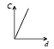
nrich.maths.org/5758/solution
- Straight Line Spin
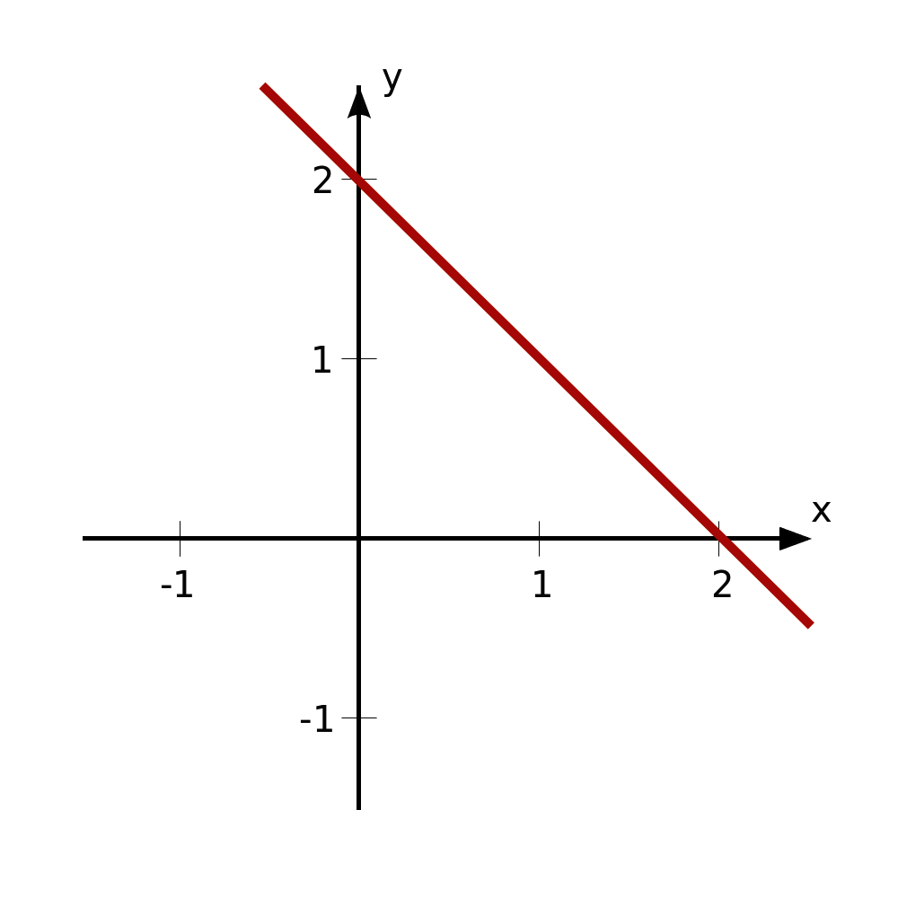
nrich.maths.org/10136/solution
- Spiral Snail
The snail finishes at (6,5)
nrich.maths.org/2441/solution

Age 14+ Level
Worksheet 1 - Solutions

- Triangular Slope
The gradient of OA is $\frac{4}{3}$
The gradient of AB is$-\frac{3}{4}$
nrich.maths.org/13592/solution

- Graph Triangles
Point P is at (4,4)
nrich.maths.org/13641/solution

- Inside a Parabola
$$k= 4$$nrich.maths.org/13036/solution

- Closer to Home
$y=x- 6$ comes closer to the origin
The shortest distance to the origin is √18 = 3√2 = 4.243
nrich.maths.org/13835/solution

- Quadratic Rotation
The equation of the new curve is
$y={-x}^{2}- 6x-11$ or $y={-(x+3)}^{2}-2$
nrich.maths.org/9435/solution

