Age 14+ Level
Worksheet 1

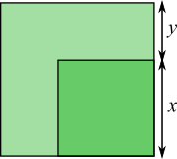
- A Third of the Area
In this diagram, the area of the small square is
$\frac{1}{3}$ of the area of the large square.
Find $\frac{x}{y}$.

- Nested Square Roots
Find the value of $\sqrt{3+2 ×\sqrt{3+2 ×\sqrt{3+2 ×\sqrt{3+2 ×\sqrt{…} }}}}$

