Age 14+ Level
Worksheet 4

- Sum = Product = Quotient
How many pairs of numbers $(a, b)$ exist such that the sum $a+b$, the product $ab$, and the quotient $\frac{a}{b}$ are all equal?

- Near 10
How many integers $n$ exist such that the difference between $\sqrt{n}$ and $10$ is less than $1$?

- Weighing Scales
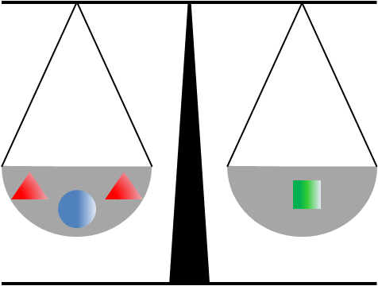
Two pyramids and a sphere on one side of a pair of scales will just balance a cube on the other side.
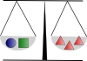
A sphere and a cube together will just balance three pyramids.
How many spheres will balance a single pyramid?

- Day of the Triffids
Jasmine spends exactly £120 on three types of plants.
Poison ivy plants cost £2 each.
Deadly nightshade plants cost £9 each.
Triffid plants cost £12 each.
She buys twenty plants in total, including at least one of each type. How many triffids did she buy?

- Algebraic Differences
If $6x–y=21$ and $6y–x=14$, what is the value of $x-y$?

- Oldest and Youngest
Edith had nine children at regular intervals of 15 months.
If the oldest is now six times as old as the youngest, how old is the youngest child?

