Age 14+ Level
Worksheet 2

- Traffic Tunnel
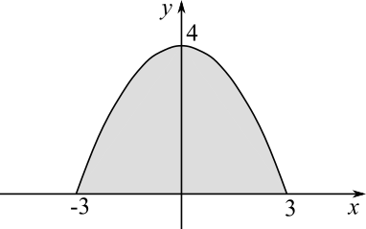
A traffic tunnel is being planned. The diagram shows the cross-section of the tunnel. The shape of the tunnel is the same as the graph of $y=\frac{4}{9}(9-x^{2})$. All distances are in metres.
Which of these vehicles will fit through the tunnel?
a) truck, 2.9 m high, 4 m wide
b) coach, 3.4 m high, 3 m wide
c) lorry, 3.9 m high, 2 m wide

- Relative Angles
In triangle ABC, angle B is $\frac{3}{4}$ of the size of angle C and $1\frac{1}{2}$ times the size of angle A.
What is the size in degrees of angle B?

- Thousands of X
Solve the equation:
$(x-2013)(x-2012)-(x-2012)(x-2011)=0$.

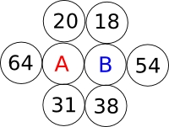
- Average Surroundings
Ali (A) and Baba (B) are shown surrounded by six thieves. The thieves' ages are given.
Ali's age is the average of his four nearest neighbours', and so is Baba's. How old is Ali?

- Tennis Training
After tennis training, Andy collected twice as many balls as Roger, and five more than Maria.
If they collected $35$ balls in total, how many did Andy collect?

