Age 14+ Level
Worksheet 1

- Simultaneous Multiplying
If $a×b=2$, $b×c=24$, $c×a=3$ and $a$, $b,$ and $c$ are all positive, what is the value of $a+b+c$?

- Well Read
In Miss Quaffley's class, one third of the pupils take a teddy bear to school. Last term, each boy borrowed 12 books from the library, each girl borrowed 17 books, and each teddy bear borrowed 9 books.
In total 305 books were borrowed.
How many girls are there in the class?

- Square to a Rectangle
Kevin had some square patio tiles which he arranged to make a square. He decided to change it into a rectangle by making one of the sides 3 tiles shorter, and the other side 4 tiles longer.
To make this change, Kevin only needed to buy one extra tile.
What are the lengths of the sides of the rectangle?

- Black and White Socks
There are 20 black socks and $n$ white socks in a drawer. When a sock is taken from the drawer, the probability that it is white is $\frac{1}{n}$.
What is the value of $n$?

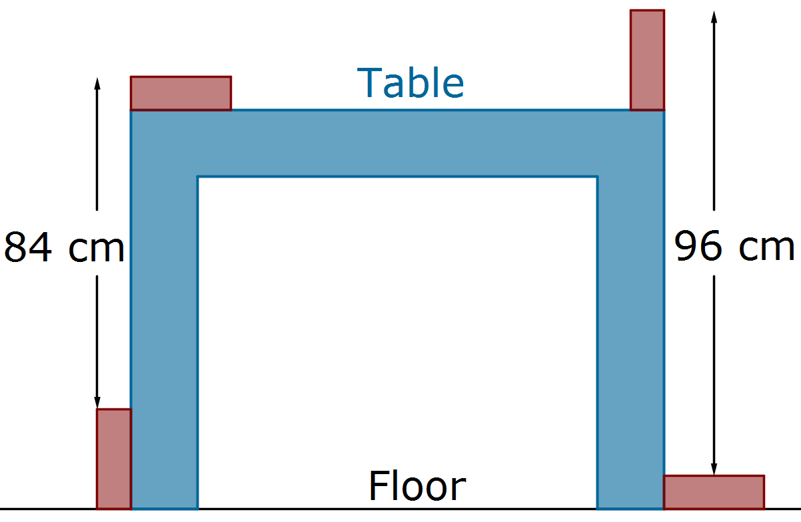
- Table Height
Four identical blocks of wood are placed touching a table in the positions shown.

How high is the table?

