Age 14+ Level
Worksheet 2
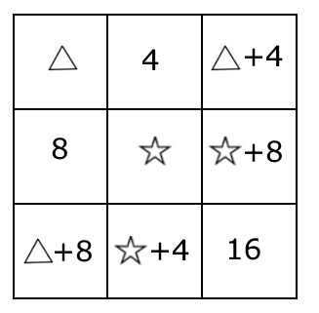
- Table Total
In each row of the table, the third cell contains the sum of the contents of the first two cells.
In each column of the table, the third cell contains the sum of the contents of the first two cells.

What total would you get if you added up the contents of all nine cells?

- Symmetric Reasoning
Find the sum of all the solutions of the equation $6x=\frac{150}{x}$

