Age 14+ Level
Worksheet 1
- Adjacent Additions
In a 7-digit numerical code, each group of four adjacent digits adds to 16 and each group of five adjacent digits adds to 19.

What is the sum of all seven digits?
- In the Hundreds
For how many positive values of $n$ are both $\frac{1}{2}n$ and $2n$ three-digit whole numbers?

- Weighing the Baby
When a mother was weighed holding her baby, the scales read 78kg.
When the nurse was weighed holding the baby, the scales read 69kg. When the nurse and the mother stood on the scales together, the scales read 137kg.

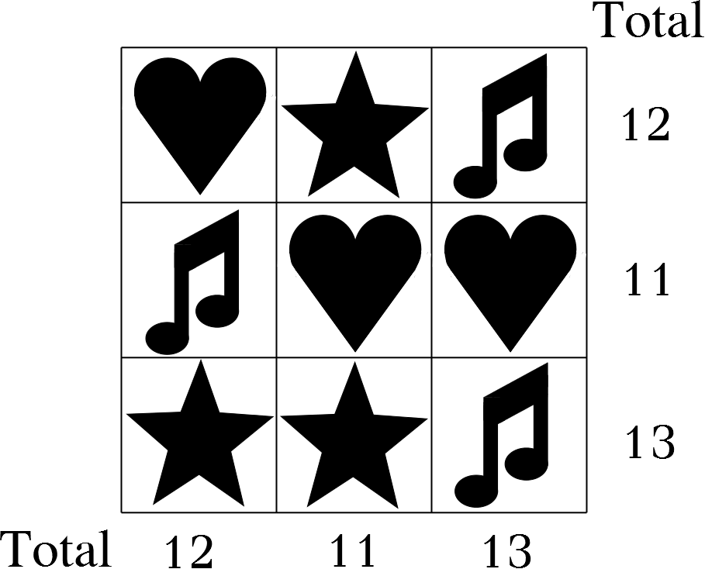
What was the weight of the baby?
- I Love Musical Stars
What is the value of  if each row
and column has the given totals?

- Bat and Ball
A ball and a bat cost £90 in total.
Three balls and two bats cost £210 in total.
How much does a bat cost?

- Pure Algebra
The sum of two numbers a and b is 7 and the difference between them is 2.
What is the product ab?

