Age 11+ Level
Worksheet 1

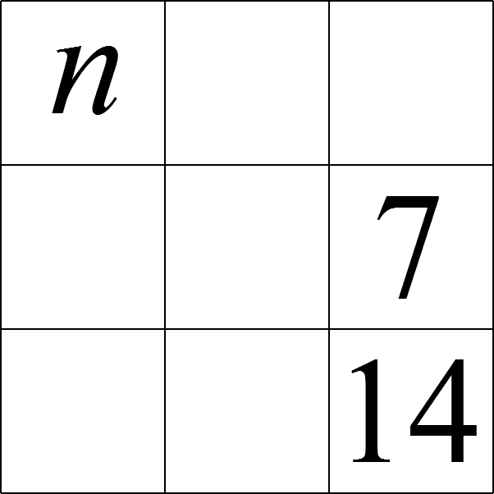
- Magic 7
In this magic square, which uses all the integers from $7$ to $15$, each of the rows, columns and the two main diagonals has the same total.

Which number replaces $n$ in the completed square?

- To Run or Not to Run?
An athlete covers three consecutive miles by walking the first mile, running the second mile and cycling the third. He runs twice as fast as he walks, and he cycles one and a half times as fast as he runs.
He takes ten minutes longer than he would do if he cycled the three miles. How long does he take by walking, running and cycling?

- Named Products
In this equation, each letter stands for a different digit:
$$\frac{E×I×G×H×T}{F×O×U×R}=T×W×O \\ What is the value of the$$product $T×H×R×E×E$?

