Age 11+ Level
Worksheet 2

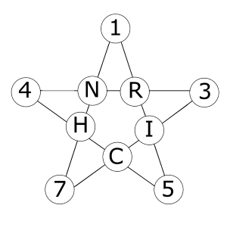
- Star Sum
In the star shown here the sum of the four numbers in any "line" is the same for each of the five "lines".
The five missing numbers are 9, 10, 11, 12, 13. Which number is represented by R?

