Age 11+ Level
Worksheet 1

- Symbol
We define$a⊕b=ab+a+b$.
If$3⊕5=2⊕x$, what is the value of$x$?
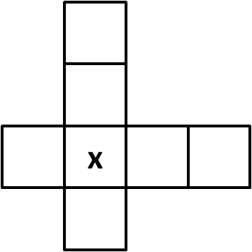
- Crossover
The numbers $2$, $3$, $4$, $5$, $6$, $7$ and $8$ are placed in the squares in this diagram.
The four numbers in the horizontal row add up to $21$, and the four numbers in the vertical column also add up to $21$.
Which number should replace $x$?

- Geometric Quadrilateral
Each interior angle in a quadrilateral (apart from the smallest) is twice the previous one.
What is the size of the smallest interior angle?

- Multiplication Mistake
Jane made a mistake when writing down a multiplication, and she multiplied by 54 instead of 45.
Her answer was 198 more than it should have been.
What number did she multiply 54 by?

- Fifty Coins
Cheryl finds a bag containing 50 coins.
The total value of the coins is £1.81.
If the bag only contains two-pence and five-pence coins, how many more five-pence coins are there than two-pence coins?

- Turnips
Baldrick can afford to buy either 6 parsnips and 7 turnips, or 8 parsnips and 4 turnips. Both options leave him with no change.
If he only bought turnips, how many could he afford?

