Age 14+ Level
Worksheet 2

- Cuboid Perimeters
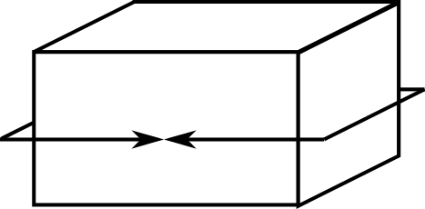
The 'perimeter' of a cuboid can be measured along three axes. One 'perimeter' of this cuboid is shown.
If the 'perimeters' of a cuboid are 12 cm, 16 cm and 24 cm, what is the volume of the cuboid?

- Relative Powers
The square of a number is 12 more than the number itself.
The cube of the number is 9 times the number.
What is the number?

- Clever Calculation
Without using a calculator, or performing any long multiplication calculations, find the value of

$${2017}^{2}-2015×2019$$

- Big Fibonacci
In a sequence of positive integers, every term after the first two terms is the sum of the two previous terms in the sequence.
If the fifth term is 2004, what is the maximum possible value of the first term?

- Granny’s Age
Granny has calculated that she is four times as old as I am now, but remembers that 5 years ago she was five times as old as I was at that time.
What is the sum of our ages now?

