Age 11+ Level
Worksheet 1

- Standing on the Table
When Clement stands on a table and Dmitri stands on the floor, Clement is 80cm taller than Dmitri.
When Dmitri stands on the table and Clement stands on the floor, Dmitri is 1m taller than Clement.
How tall is the table?
- Square Total
Anastasia thinks of a positive integer.
Barry doubles Anastasia’s number.
Connor trebles Barry’s number.
Damion multiplies Connor’s number by 6.
Eve notices that the total of the four numbers is a perfect square.
What is the smallest positive integer that Anastasia could have thought of?

- Adding in Pairs
Three whole numbers, when added two at a time, give sums of 39, 48 and 51.
What is the largest of the three numbers?

- Multiple Magic
Think of any whole number. Double it and add five.
Double this answer and add two.
Now take away the number you first thought of.
Your answer will always be a multiple of which number?
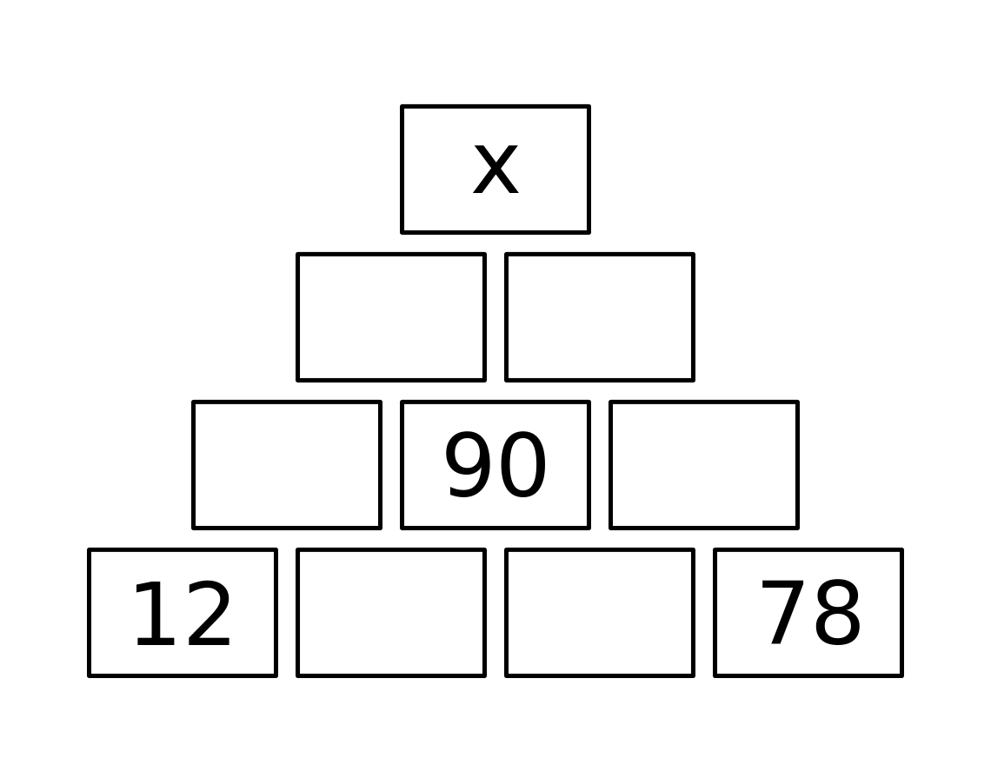
- Building Up
In the diagram, the number in each box is obtained by adding the numbers in the two boxes immediately underneath.
What is the value of $x$?

